**LAB 2**

**Creating Virtual Machine**

**Understanding Azure Virtual Machines**

Azure offers several highly [scalable computing resources on-demand](https://docs.microsoft.com/en-us/azure/architecture/guide/technology-choices/compute-decision-tree), and [**Azure Virtual Machine**](https://www.whizlabs.com/blog/azure-70-533-creating-virtual-machines/)is one of them. If you require more control over the computing environment than the other computing resources offer, then you should opt for an **Azure Virtual Machine**.

With **Azure Virtual Machine,**you get the flexibility of accessing a virtual platform without buying and maintaining the physical hardware that can run the operation. But you will also need a proper maintenance plan for your **Azure Virtual Machine**while performing tasks like configuring, patching, parsing, and installing the softwares to run on the virtual machines.

There are wide use cases of **Azure Virtual Machine,**but some examples in

### **Cloud Applications**

Your requirement of running applications will constantly change based on your business. Using **Azure Virtual Machine**is a cost-effective solution that can allow you to pay for extra virtual machines whenever you need them. When out of use, you can shut down these virtual machines.

### **Extended Data Center**

You can easily connect your organization’s network to an **Azure Virtual Machine**available in the network.

### **Development**

If you need a computer with a definite configuration to write a code or test any application, then **Azure Virtual Machine**can be a feasible way to go about the process. Whatever be the extent of your requirement, you can scale up using **Azure Virtual Machine**and streamline your workflows.

## Considerations before creating an Azure Virtual Machine

Whenever you set out to build an application infrastructure using Azure, there are several [design considerations](https://docs.microsoft.com/en-us/azure/architecture/reference-architectures/n-tier/windows-vm) to note. Before deciding upon creating an **Azure Virtual Machine**, there are a few things that you must think about, like:

* The names of the application resources that you use on **Azure Virtual Machine**
* The storage [location](https://azure.microsoft.com/regions/) of the resources
* [Size](https://docs.microsoft.com/en-us/azure/virtual-machines/sizes) required for the **Azure Virtual Machine**
* [Maximum number of virtual machines](https://docs.microsoft.com/en-us/azure/azure-resource-manager/management/azure-subscription-service-limits) that you may require to create
* The [operating system](https://support.microsoft.com/help/2721672/microsoft-server-software-support-for-microsoft-azure-virtual-machines) of the **Azure Virtual Machine**
* The configuration of the virtual machine after starting up
* All kinds of related resources and [extensions](https://docs.microsoft.com/en-us/azure/virtual-machines/extensions/features-windows?toc=/azure/virtual-machines/windows/toc.json) that the **Azure Virtual Machine**requires

Now that you are equipped with the basic information about **Azure Virtual Machine,**it is time to get started with creating the virtual machine.

**Step-1:** Login to [https://portal.azure.com](https://portal.azure.com/).

**Step-2:** Now click on **“Virtual machines”**option from the left side Menu and then click on**“Create”** link.

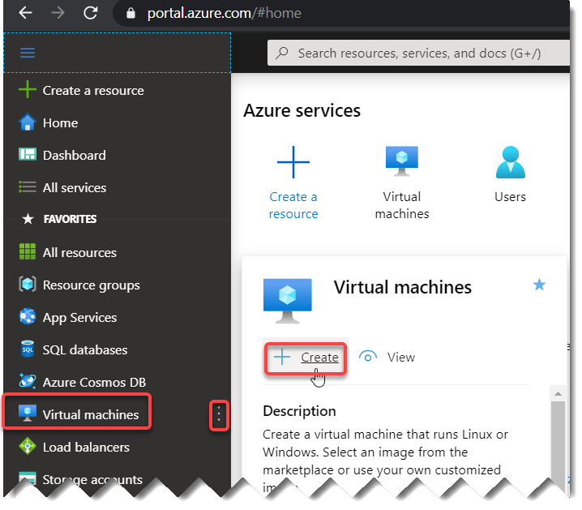

**Or**Go to **“Virtual machines”** option from the **“Azure services”** section.

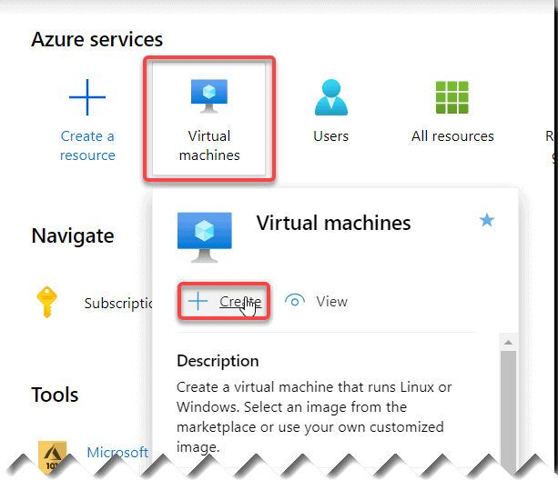

One more way is to go to the same option fromthe**“Create a resource”** link from the left side menu and then select the**“Compute”** and **“Virtual machine”**.

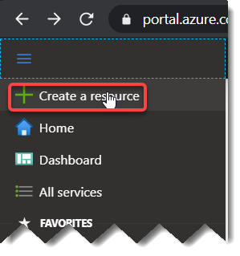

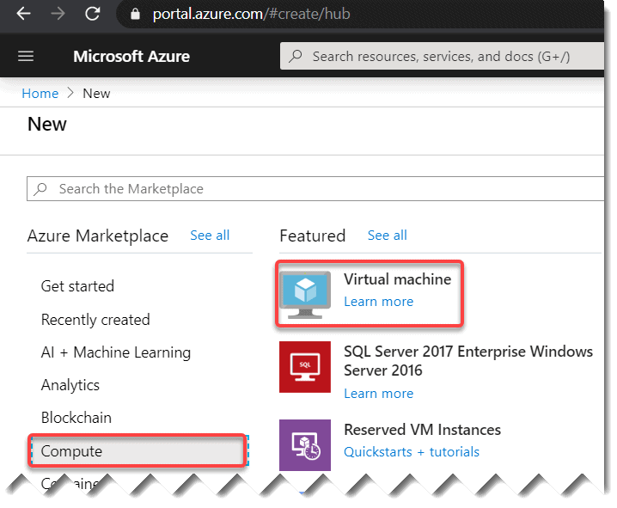virtual machine in azure

Or else for the same option you can go to the**“Create a resource”** link from the **“Azure services”** section and then select the**“Compute”** and **“Virtual machine”**.

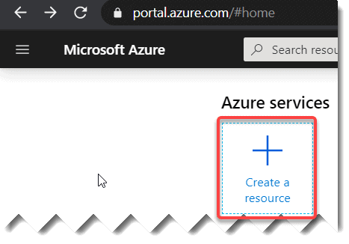

You can see the option “Virtual machine’ like below:



**Step- 3:** Fill the details required. A few of the options you can keep as it is but based on your business need you can change those.

* [**Subscription**](https://azurelessons.com/you-are-not-eligible-for-an-azure-subscription/): Choose your correct subscription.
* [**Resource group**](https://azurelessons.com/what-is-resource-group-in-azure/): You can choose the existing resource group or you can create a new one by clicking the “**Create New**” option. It acts like a container that stores the resources related to an Azure solution.
* **Virtual machine name**: Provide a name for your virtual machine.
* **Region**: This the location where you are going to create all the resources related to the virtual machine.
* **Image**: Choose the **Windows Server 2019 Datacenter**. You can change it based on your business need.
* **Size**: The size you want to assign based on your requirement. I have chosen **Standard D2s v3** as per my business requirement.

In the Administrator account section, Choose a **Username, Password** that you will use to login to the VM once created.

**Select Inbound port:**Choose **HTTP(80),RDP(3389)**. This is a very important option.

All other options you can keep as it is. Now click on “**Next:Disks** **>**” button.

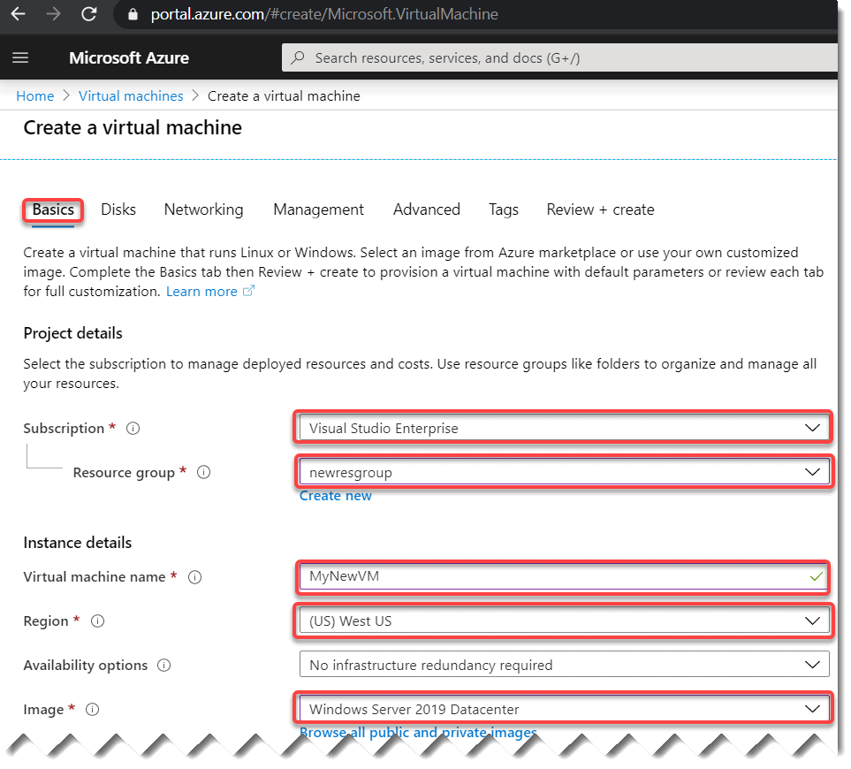

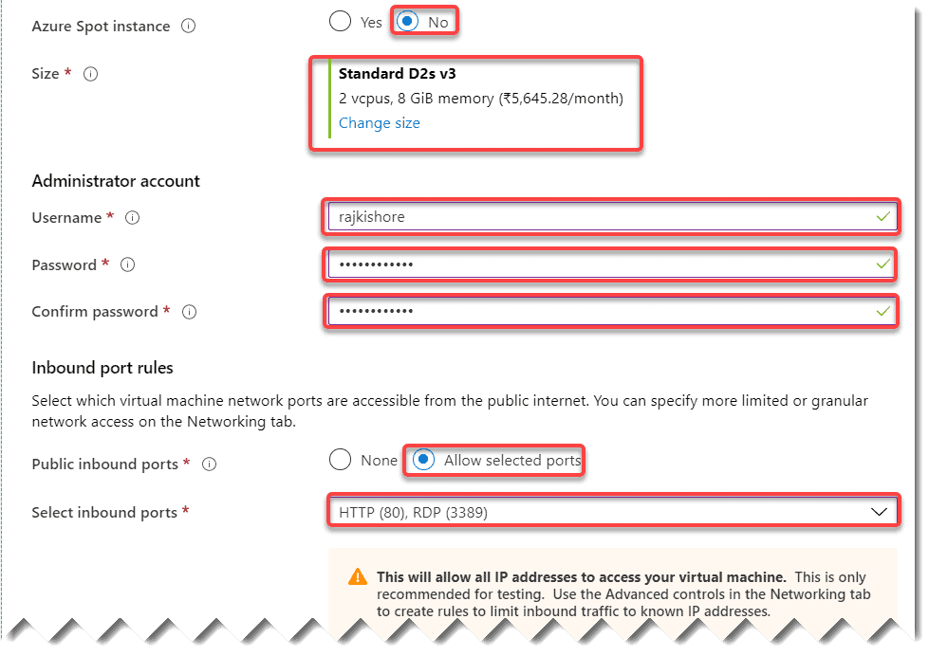

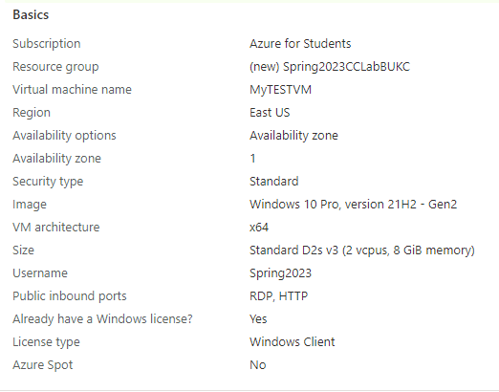



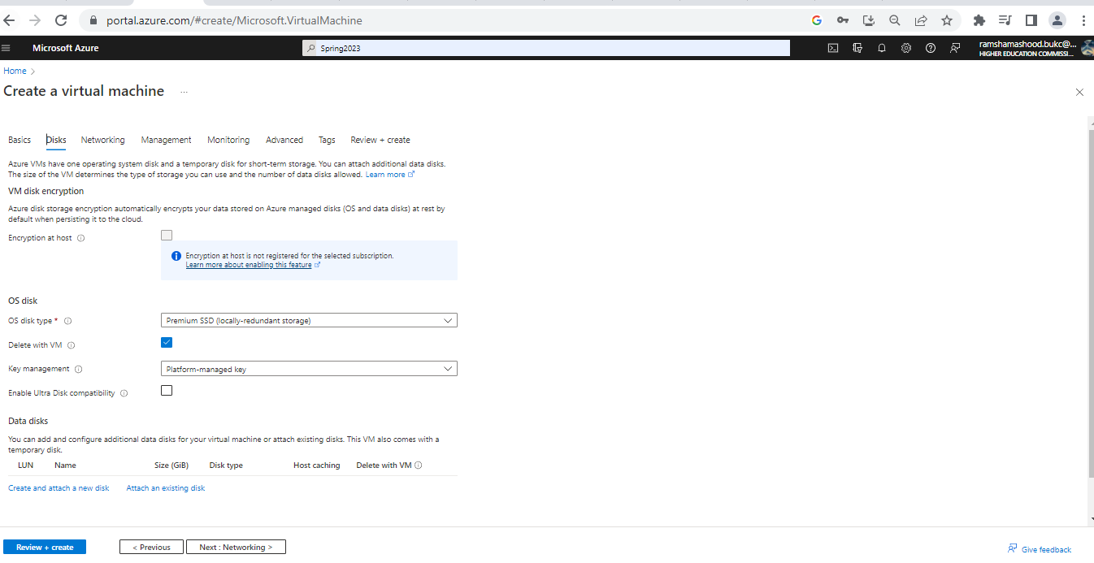

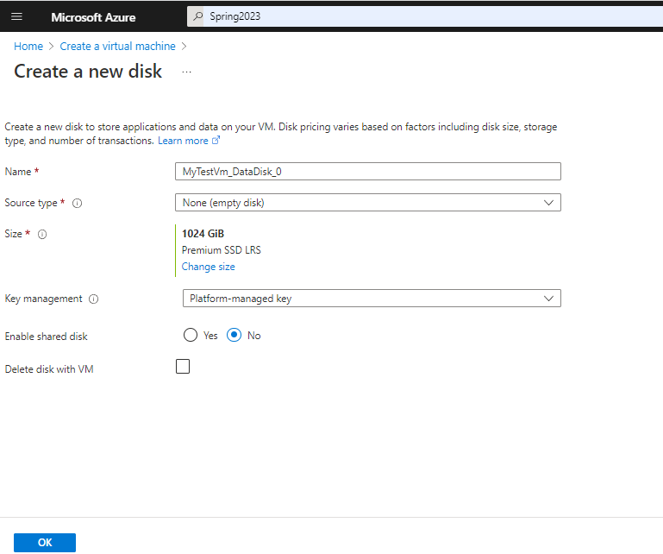

In the next screen**(Disks)**, you can add the disk architecture that you want. I kept the default option as it is. You can change it based on your business need. Click on **Next: Networking** button

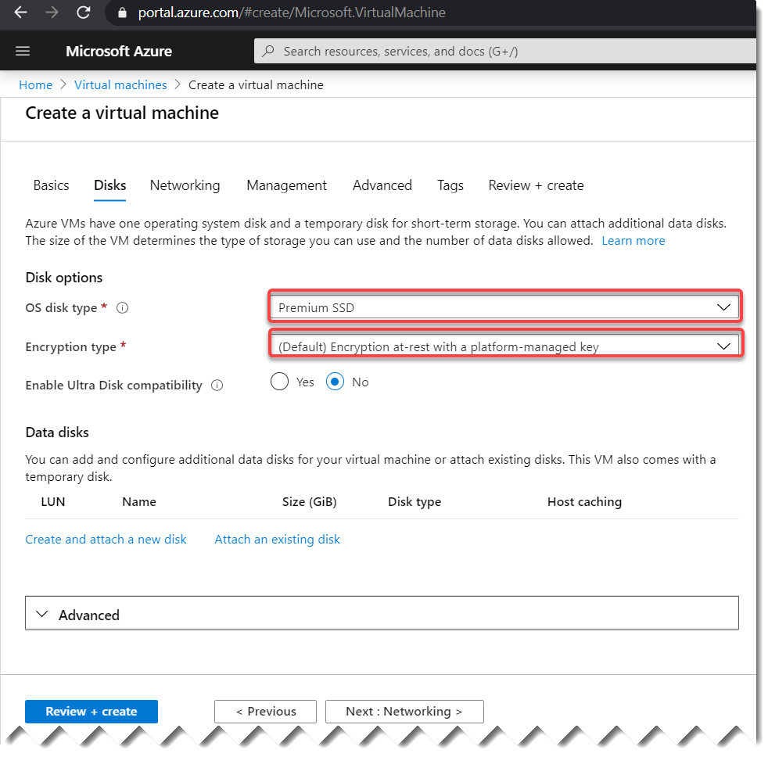.



Now you can fill the below details in the Networking screen.

* **Virtual Network**: Choose a **virtual network** or else you can create a new one by clicking the **“Create New”** link.
* **Subnet:** You can keep the default option as it is.
* **Public inbound ports**: choose **Allow selected ports**.
* **Select inbound ports**: This is a very important option. Choose the option as **HTTP(80), RDP(3389)** here. Once you choose this option in the Basics tab it will automatically show the same option here. Keep the option as it is.

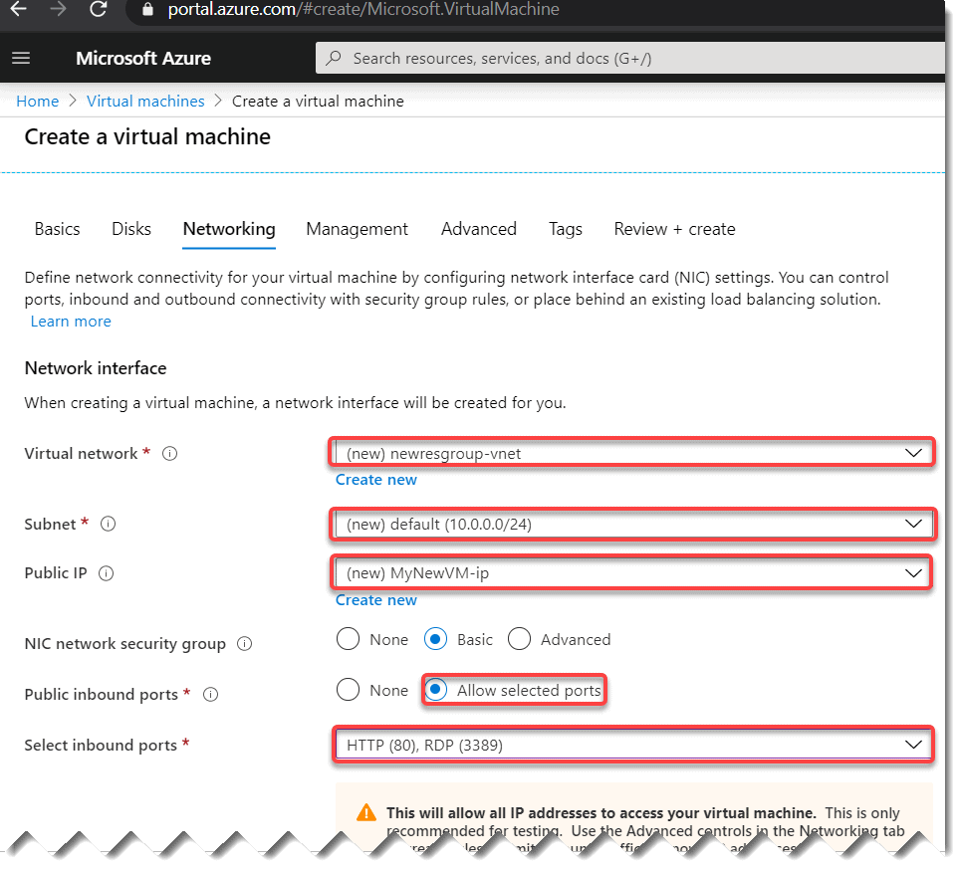

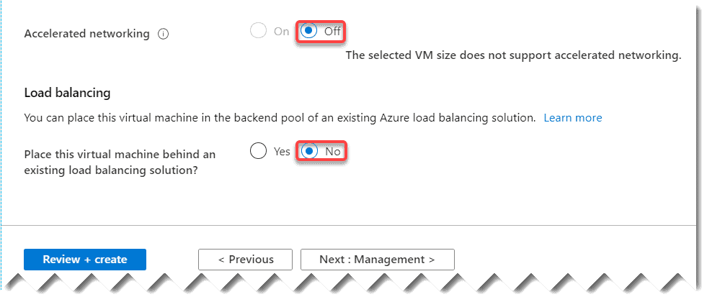

Now for other tabs all the options you can keep as it is. Once you fill all the above details click on the **“Review + Create”** button. Azure will validates the above details internally and will show a message **“Validation passed”**.

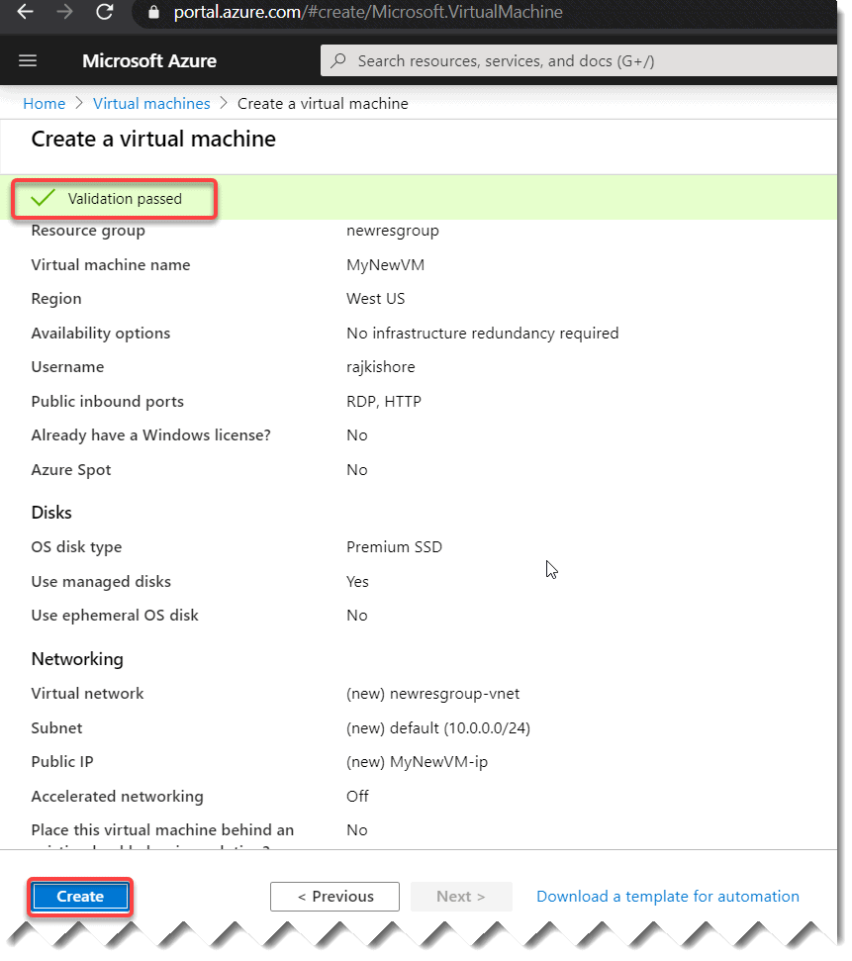

**Step- 4:** Now click on the “**Create**” button. It will show you “**Your deployment is complete**“.Now click on **“Go to resource”**

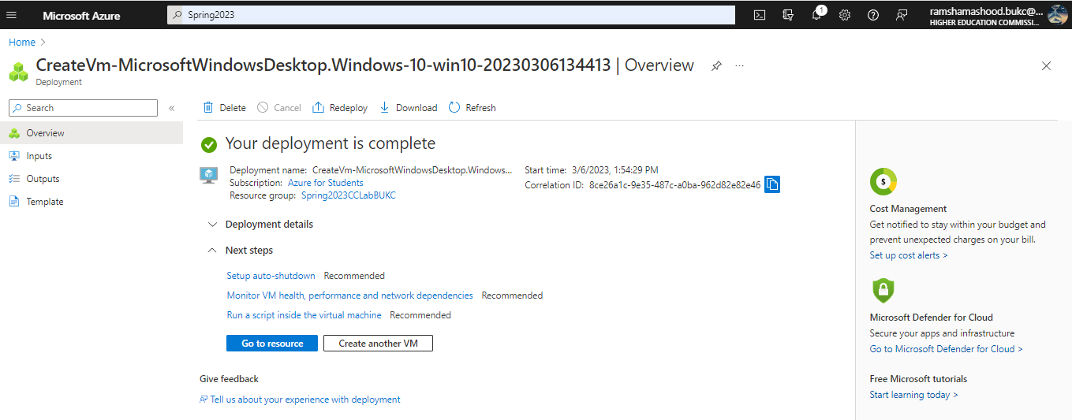

**Step- 5:**Congratulations, Now you have created the VM successfully.

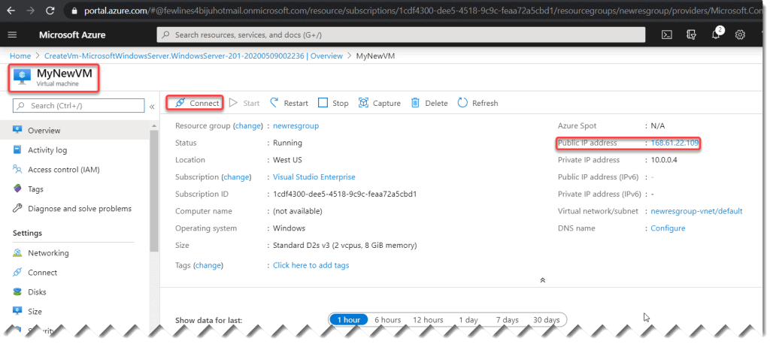

Step-6: Click on the **Connect button** to connect to the VM.

